Primarily Me 1: Out My Window
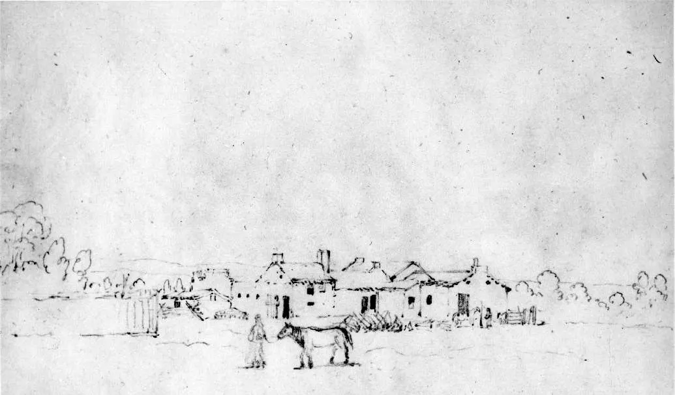
Sketch of Whitman Mission by Paul Kane done in 1847
Royal Ontario Museum
When telling a story, we usually start by setting the scene. The sketch above is of Whitman Mission in 1847 by artist Paul Kane. It may look like there is not a lot of detail, but we can still learn something about life at the mission when we look at it. What does the sketch tell you about life at the mission in 1847?
Activity 1: Set the Scene
Now it’s your turn to set the scene. Where does your story take place? Take a couple of minutes to look out your window and note what you see. Are there animals, plants, people, or buildings?
The first Primarily Me challenge is to record what you see. You could draw, paint, or write a poem about what is out your window
You might want to ask yourself...
- What is my favorite thing about where I live?
- What is special about where I live?
- What kinds of animals are there and what are they doing?
- What kinds of plants are there? What do they look like?
- Are there a lot of buildings? Are the buildings new or old, big or small, close together or far apart?
- Are there people or signs of people like cars, lawn decorations, or businesses?
- What is the weather like?

What is an Oral History?
An oral history is what you get when you ask someone questions about their own experience to learn more about history or culture. Stories can last a very long time when they are passed down from one person to another, so you can even use oral histories to learn about things that happened hundreds of years ago. A lot of what we know about Cayuse history and culture comes from oral histories.

Activity 2: Plan an Oral History Project
The next challenge is to think of someone who knows a lot about something you want to learn about and come up with five questions you would ask them! Below are some basic tips for getting started and writing your questions.
Picking a Topic:
Before you think of questions, you need to decide what it is that you want to learn about! Once you have a topic, think about who you could ask that might be able to teach you more. Even if you don't ask them your questions, it will be easier to write them if you have an idea of who you would ask. You might want to learn about:
- Your family history. Do you know someone in your family who could tell you about other family members, where your family is from, or things that are special to your family?
- What it is like to live somewhere else. Do you know someone who has lived in another place?
- What it was like living in a different time. Do you know someone who is older than you who could tell you about life during a different time in history?
- How to make or do something. Do you know someone who has a skill that you want to learn about? Maybe they know how to cook, fix something, create a type of art, play a game or sport, or do another activity you are interested in.
Think about...
- Why you want to learn about the topic you have picked
- How the person might answer. What follow-up questions could you ask?
- What questions could lead to stories or longer answers
- What questions you would want to be asked if someone was interviewing you

Activity 3: How Do You Spend Time Outdoors?

Did you know Whitman Mission protects the outdoor area of the park? We know some of the ways people used these places in the past because they recorded it through primary sources like oral histories and journals. How do you think people might have used these places in the 1800's?

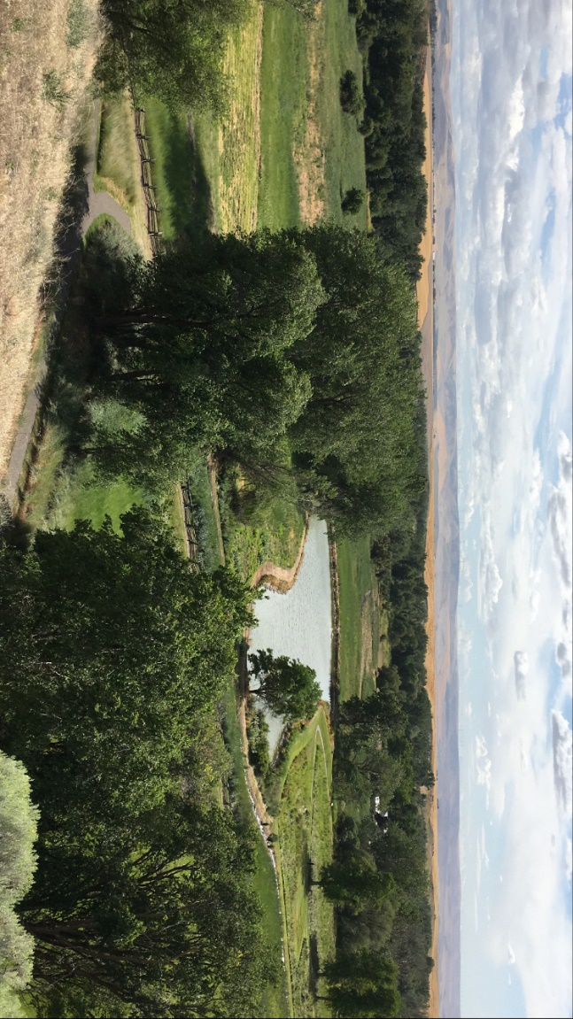

The mountains that surround the park are called the Blue Mountains. Many Cayuse people would go to the Blue Mountains to gather berries and hunt large animals for food. The missionaries used the trees from the mountains to build things. There were not as many trees around the mission site then as there are now.

The pond is a mill pond. It was not always here. The missionaries built it so they could use the water to power a grist mill. A grist mill is something that is used to grind wheat to make flour for baking.

The open fields are between two rivers and are much lower than the tall mountains in the background. Places that are lower are also warmer. Some Cayuse families chose to spend the winter in this area because they would be warmer and could get water from the rivers.
Where is your favorite place to be outside? What do you do when you are there?
Primarily Me challenge number three is to record your favorite outdoor spot. It could be your backyard, somewhere you visited on a trip, or a nearby park! Think about why that spot is your favorite. Maybe it’s the best place to play your favorite game or to spot your favorite animal. Maybe it makes you feel happy, adventurous, or calm. When you record your favorite spot, try to show why it is important to you and what you do there.
Since you may not be able to go to your favorite spot right now, you could create an album of photos from your last visit, draw what you remember, or write a story about the last time you went there.

Recording Memories

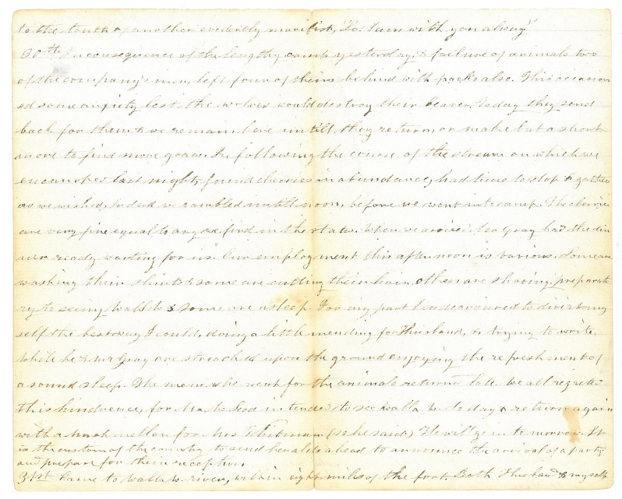
How do you record things that you want to remember?
Many Cayuse women created a time ball. Time balls are like journals but use string, beads, and knots to represent events and the passing of time. Similarly, many missionary women created written journals. Even though a time ball and a written journal are different, they both help the creator remember their experiences and share them with others.
Here is a page from Narcissa Whitman's journal:
to the truth of another evidently manifest, “Lo! I am with you alway.”
30th In consequence of the lengthy camp yesterday, & failure of animals two of the company’s men, left four of theirs behind with packs also. This occasioned some anxiety lest the wolves would destroy their beaver. Today they send back for them & we remain here untill they return, or make but a short move to find more grass. In following the course of the stream on which we encamped last night, found cherries in abundance, had time to stop & gather as we wished, Indeed we rambled untill noon, before we went into camp. The cherries are very fine equal to any we find in the states. When we arrived Mr Gray had the dinner ready waiting for us. Our employment this afternoon is various. Some are washing their shirts & some are cutting their hair, others are shaving preparatory to seeing Wall W & some are asleep. For my part I endeavoured to divirt myself the best way I could, doing a little mending for Husband, & trying to write, while he & Mr Gray are streached upon the ground enjoying the refreshment of a sound sleep. The men who went for the animals returned late. We all regretted this hindrence, for Mr McLeod intended to see Walla W. today & return again with a mushmellon for Mrs Whitman (so he said) He will go in tomorrow. It is the custom of the country to send heralds ahead to announce the arrival of a party and prepare for their reception.
31st Came to Walla W. river, within eight miles of the fort. Both Husband & myself
- What part of Narcissa's journal entry surprised you?
- What reminded you of your own life?
- Which words or ideas were confusing?

Activity 4: Create Your Own Journal
The fourth Primarily Me challenge is to record what you want to remember by starting your own journal. Remember, you don't have to write things down like Narcissa did for it to be a journal. You could draw sketches of your life, put pictures together like a scrapbook, or find your own style!

Flags and Other Symbols
A symbol is something that stands for or represents something else. Even though they may need some decoding, symbols can be useful primary sources. For example, if you visited Fort Walla Walla in the 1830’s, the flag that flew over the fort could tell you that it was a British company, Hudson’s Bay Company, that ran the fort. It also might remind you that this area was not a part of the United States yet. If you talked to people around the fort, you might notice different symbols representing their job or status, religious beliefs, or their nationality.
The historic flag of the Hudson's Bay Company and the modern-day flag of the Confederated Tribes of Umatilla Indian Reservation are below.

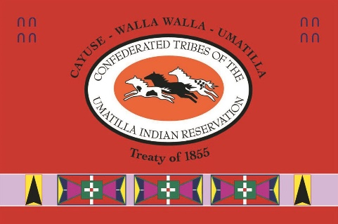
Historical Hudson's Bay Company Flag Current flag of the Confederated Tribes of . Umatilla Indian Reservation.
- What symbols do you see on the flags above?
- What do you think the symbols might stand for?
- Why might someone fly a flag? What purpose does it serve?

Activity 5: Create Your Own Flag
This week's Primarily Me challenge is to create your own flag to represent a group that you are a part of. You could create a flag for your family, your school, your friends, or a club you are in.
To get started on your own flag, ask yourself:
- What groups are you a part of?
- What brings everyone in your group together?
- What symbols could you use to represent those things?

Find Out From Fashion
- What is your favorite fashion trend right now?
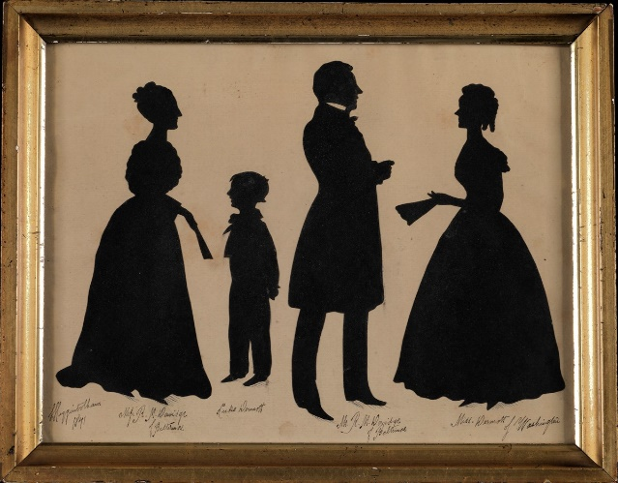
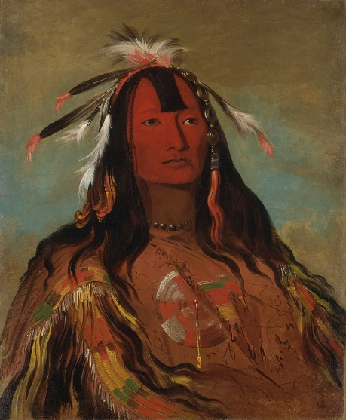
- We can learn a lot about history through the clothing and accessories that people wore. We can learn what resources were available from the fabric or materials that were used. The style of someone’s clothing might tell us something about what climate they lived in, how they celebrated special occasions, or their job. On top of wider trends, we can also learn about how people expressed their own style and personality.
Clothing itself can be a primary source, but what people wear can also be recorded through things like paintings, photographs, and written descriptions. Look for yourself! Below are a few different primary sources that show clothing from the 1800s.

These silhouettes of a family were created by
Higginbotham in 1841. Smithsonian Institute
Portrait of Hee-oh'ks-te-kin painted by George Object Number 1981.172.32 Catlin in 1832. Smithsonian Institution Object,
Number 1985.66.145

- Each of these primary sources uses a different method to record history. What materials do you think were used to make each source?
- What materials do you think were used to make the clothing represented in each source?
- How is the clothing here different from what you wear? How is it similar?
- Ask your parents, grandparents, or other family or friends what their favorite thing to wear was when they were your age! How is it different or similar to what you wear?

Activity 6: Show Your Style
The next Primarily Me challenge is to record your favorite things to wear! You might paint like George Catlin, use paper to make a silhouette like Higginbotham, or take photos like countless photographers to recreate your favorite clothing items.
If you want to use the clothing itself as your record, you could even put on a fashion show for your family!

What's Missing?
What is the most boring part of your day?
Sometimes the things we think are boring don’t make it into the records we create. Things that seem commonplace, things that “everyone does,” aren’t always recorded because it seems like everyone already knows about them. But as those things change over time, that information can be lost.

Where are the Buildings?
Many people who visit Whitman Mission have one question: Where are the buildings?
The buildings themselves would be a great primary source for learning about where the missionaries lived and worked. The buildings burned down, so they are no longer there for people to learn from. Without the buildings, some information is lost.
The foundations, the lower support of the buildings, survived though! We can still learn some details about the buildings by looking at the foundations and other primary sources that survived like:
- A floorplan of the main house. A floorplan is like a map of where the rooms were.
- A sketch of the main house by artist Paul Kane.
- Written descriptions of the buildings and how they were used. Written descriptions come from the letters and journals of people who lived, worked, and visited the mission.

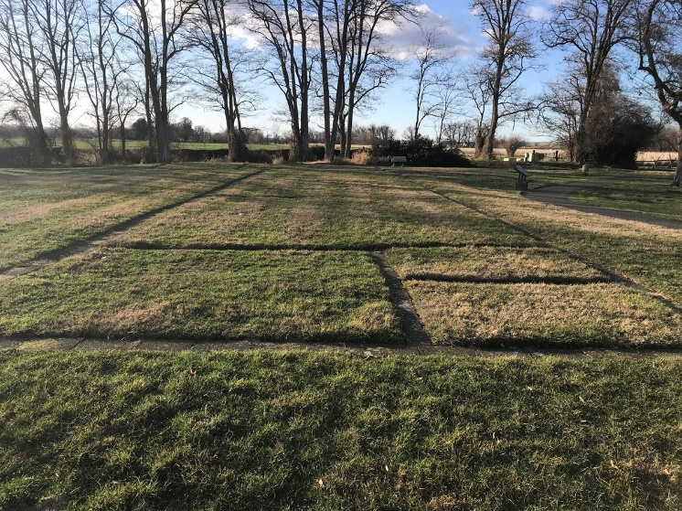
Activity: Filling the Gaps
So what is missing from your own record? This week’s Primarily Me challenge is to record three things that are missing from the records you have created so far. You might want to:
- Take a picture each day
- Write a story
- Or add to the records you've made over the past few weeks!
Are you worried about making sure your primary sources survive? Don't worry! Our last challenge will be all about keeping your records safe.

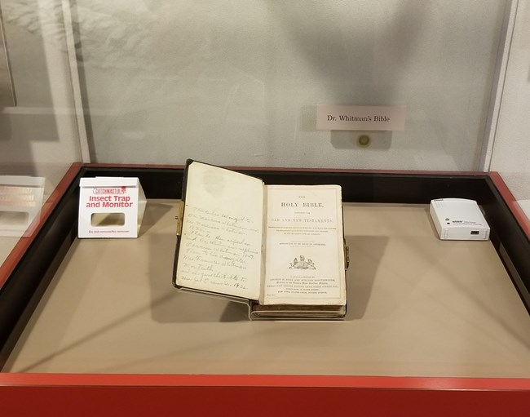
Keep it Safe
Have you ever accidentally spilled water on your favorite book? Or left something you love in a spot that’s a little too easy for your pet to reach? Let’s face it, accidents happen. So how do some things survive hundreds or even thousands of years?
In Week 7, we looked at what is missing from primary sources and why they sometimes don't survive the test of time. Let's revisit some of those ideas to explore what we can do to help records last longer.

There are a lot of things that can harm primary sources depending on the type of material that was used. There are also a lot of ways to stop those things from hurting them! You can...
- Put it in a safe spot where accidents are less likely to happen. Keep it in an organized place away from pets, pests, food, and drinks.
- Control the climate that it is in. The climate includes things like the temperature and how much water is in the air. The less the climate changes, the less you need to worry about your record! Things like air conditioning or heaters help you control the climate inside.
- Keep it out of direct light. Light can cause colors to fade.
- Make a copy. Taking a picture, scanning it, or backing up digital files will give you a way to hold on to your primary sources in case an accident does happen.
- Wear gloves when you touch it. Our skin has oils that can cause problems for primary sources after being touched a lot over a long time.
The best way to make sure people still understand your primary source in the future is to talk about it! We learned in Week 2 how oral histories can help us pass on stories and information. Just like oral histories, talking about what you created with other people like your family and friends will help people understand your story longer.

Activity: Make it Last
The final Primarily Me challenge is perhaps the most important one. You've worked so hard to record parts of your story, and now it is time to make it last!
Choose two or more of the actions listed above (in bold) to keep the records you created and your story safe. Don't worry, you don't have to do them all, whichever you choose will make a difference!
The challenge of caring for your primary sources never really ends, and recording your story doesn't have to either! Remember, each primary source shares a perspective or point of view, and your perspective matters. Because you completed the Primarily Me challenge, people in the future will be able to learn about life today and your perspective! Good job!

